Venice, Island of San Giorgio Maggiore
12 May – 12 July 2017

Alighiero Boetti: Minimum/Maximum
curated by Luca Massimo Barbero
with a special project by Ulrich Obrist and Agata Boetti

An exhibition celebrating the genius of the Turin artist with over twenty striking works selected for the first time according to format to produce a comparison of “minimum” and “maximum” in his most significant series

Curated by Luca Massimo Barbero with the Archivio Alighiero Boetti, the show includes a special project by Hans Ulrich Obrist and Agata Boetti on the theme of the photocopy, entitled COLOUR = REALITY. B+W = ABSTRACTION (except for the zebras)

From 12 May to 12 July 2017, the Island of San Giorgio Maggiore, Venice, will host a highly original, wide-ranging journey of discovery into the work of Alighiero Boetti, a leading 20th-century Italian artist, at a time when his art is enjoying great popularity. Curated by Luca Massimo Barbero, the Director of the Institute of Art History at the Fondazione Giorgio Cini, with the collaboration of the Alighiero Boetti Archive, Alighiero Boetti: Minimum/Maximum shows the results of an unprecedented selection and comparison: the exhibition will explore the contrast between the smallest and largest formats of all the most representative series of works by the Turin artist, thus focusing on one of the themes that best illustrate Boetti’s creative procedures. The exhibition has been organized by the Fondazione Giorgio Cini in collaboration with Tornabuoni Art.
“The exhibition enables viewers to explore a non-anthological and highly unpredictable itinerary of relations, unique in its kind, created by bringing together Boetti’s large-sized works from public and private collections”, explains Luca Massimo Barbero. “It is the result of a coherent project specially conceived for Venice at a time of great international acclaim for one of the most important exponents of Italian art.”

Divided into sections with a total of over twenty works, the exhibition includes Boetti’s most significant series (Embroideries, Maps, Everything and Biro), and some lesser known works such as Coloured Tokens, The Natural History of Multiplication and Covers. There are also some previously never publicly shown works, such as the coloured tokens of Summer 70 (1970) – loaned directly by the artist’s family – and Titles (1978), one of the largest formats in the monochrome Embroideries. In the exhibition there will also be one of the largest works from Mimetic (1967), a very early Boetti series, on loan from the Fondazione Prada.

The format is a crucial theme in understanding how Boetti conceived and produced his works. It is directly connected to the concept of time as, for example, in the first work on the exhibition itinerary, Summer 70, a roll of paper twenty metres long, on which Boetti stuck thousands of self-adhering tokens. This work is unique in terms of its size and for having introduced in such a striking way the theme of the time required to contemplate a work of art. Meaningful in a complementary way, the minimum-format works represent the other extreme in the dialectical opposition in Boetti’s creativity.

The exhibition unfolds as a precise comparison between small and large formats (minimum and maximum), with works such as The Natural History of Multiplication, Bringing the World into the World and Alternating from One to a Hundred and Vice Versa. Viewers can thus explore in a single setting works from very different periods up to the large triptych Aeroplanes (1989), on loan from the prestigious Fondation Carmignac, Paris.

In an area between the first and second rooms, a documentary will be shown: Nothing to See, Nothing to Hide made in 1978 by Emidio Greco at the time of the Boetti retrospective at the Kunsthalle, Basel. The film intersperses sequences from the Swiss exhibition with visits to the artist’s Roman studio and some significant direct comments from Boetti.

The itinerary continues with the celebrated Maps and Everything, “a miscellany of Boetti’s themes and images” – explains Barbero – introducing the important topic of the deferred realisation of a work of art, through travel and nomadism, in turn interrelated with the theme of time. This element emerges powerfully in the Embroideries, which having been begun by assistants in Rome, were sent to Kabul and then to Peshawar, following the Soviet invasion of Afghanistan in 1979. In the Pakistan city embroiderers from Afghan refugee families made the works by juxtaposing colours of their own choice but following the rules of the game dictated by Boetti. The works eventually returned to Rome, where the artist saw the final result for the first time.

The section of comparisons ends with the large-scale work entitled Covers (1984), which returns to the idea of the media’s obsessiveness and the formula of the transmitted and reused image, thus introducing the special project curated by Hans Ulrich Obrist, Artistic Director of the Serpentine Gallery, London, and Agata Boetti, Director of the Archivio Alighiero Boetti. The project further illustrates Boetti’s essentially dialectical approach, in this case in addressing the theme of the photocopy. As the artist himself commented in 1991: "Back in 1969 in Turin, when I used to go to the Rank Xerox showroom with coins in my pocket, I got lots of ideas. I used to think that the photocopier was not only an office machine. By the year 2000 we will all have one in our living rooms. Just give me one and I will show you how to put it to creative use. I didn't want to tamper with the mechanism or ink, as some people did from Munari onwards. What I was interested in was the standard application. But, for example, I might have put it outside on my balcony when it began to rain – one drop, ten drops, one thousand drops.”

COLOR=REALITY. B+W=ABSTRACTION (except for zebras) explores Boetti’s creative applications by bringing together for the first time a group of works made with the photocopier at various times in his career. According to Hans Ulrich Obrist, they illustrate Boetti’s passion for communication technologies (such as the Polaroid or the fax machine which, in the 1980s, introduced a combination of mailing and photocopying). The show invites people to imagine the creative uses that Boetti would have found for today’s means of communications and multiplication of images: “By displaying these works on the walls, as we are doing with the 1,665 photocopies at the Fondazione Cini, we will show the public that Boetti was a kind of analogical version of the Internet. He was a search engine and anticipated Google with analogical means.”

Visitors are even invited to use a real photocopier at the centre of the room, but following the rules of a game specially created by the Mexican artist Mario Garcia Torres to pay homage to Boetti.

Alighiero Boetti: Minimum/Maximum curated by Luca Massimo Barbero, and the special project COLOUR = REALITY. B+W = ABSTRACTION (except for the zebras), curated by Hans Ulrich Obrist and Agata Boetti, have separate catalogues, both published by Forma Edizioni.

Practical information:
Title: Alighiero Boetti: Minimum/Maximum with the special project COLOUR = REALITY. B+W = ABSTRACTION (except for the zebras)
Production: Fondazione Giorgio Cini onlus and Tornabuoni Art
Curators: Luca Massimo Barbero, Hans Ulrich Obrist and Agata Boetti
Date: 12 May - 12 July 2017
Open: 11 am – 7 pm, closed on Wednesdays
Venue: Venice, Island of San Giorgio Maggiore
Tickets: free admission
Catalogues: Forma Edizioni
Info: info@cini.it
Web: www.cini.it, www.boetti-venice.com

In collaboration with



With the support of

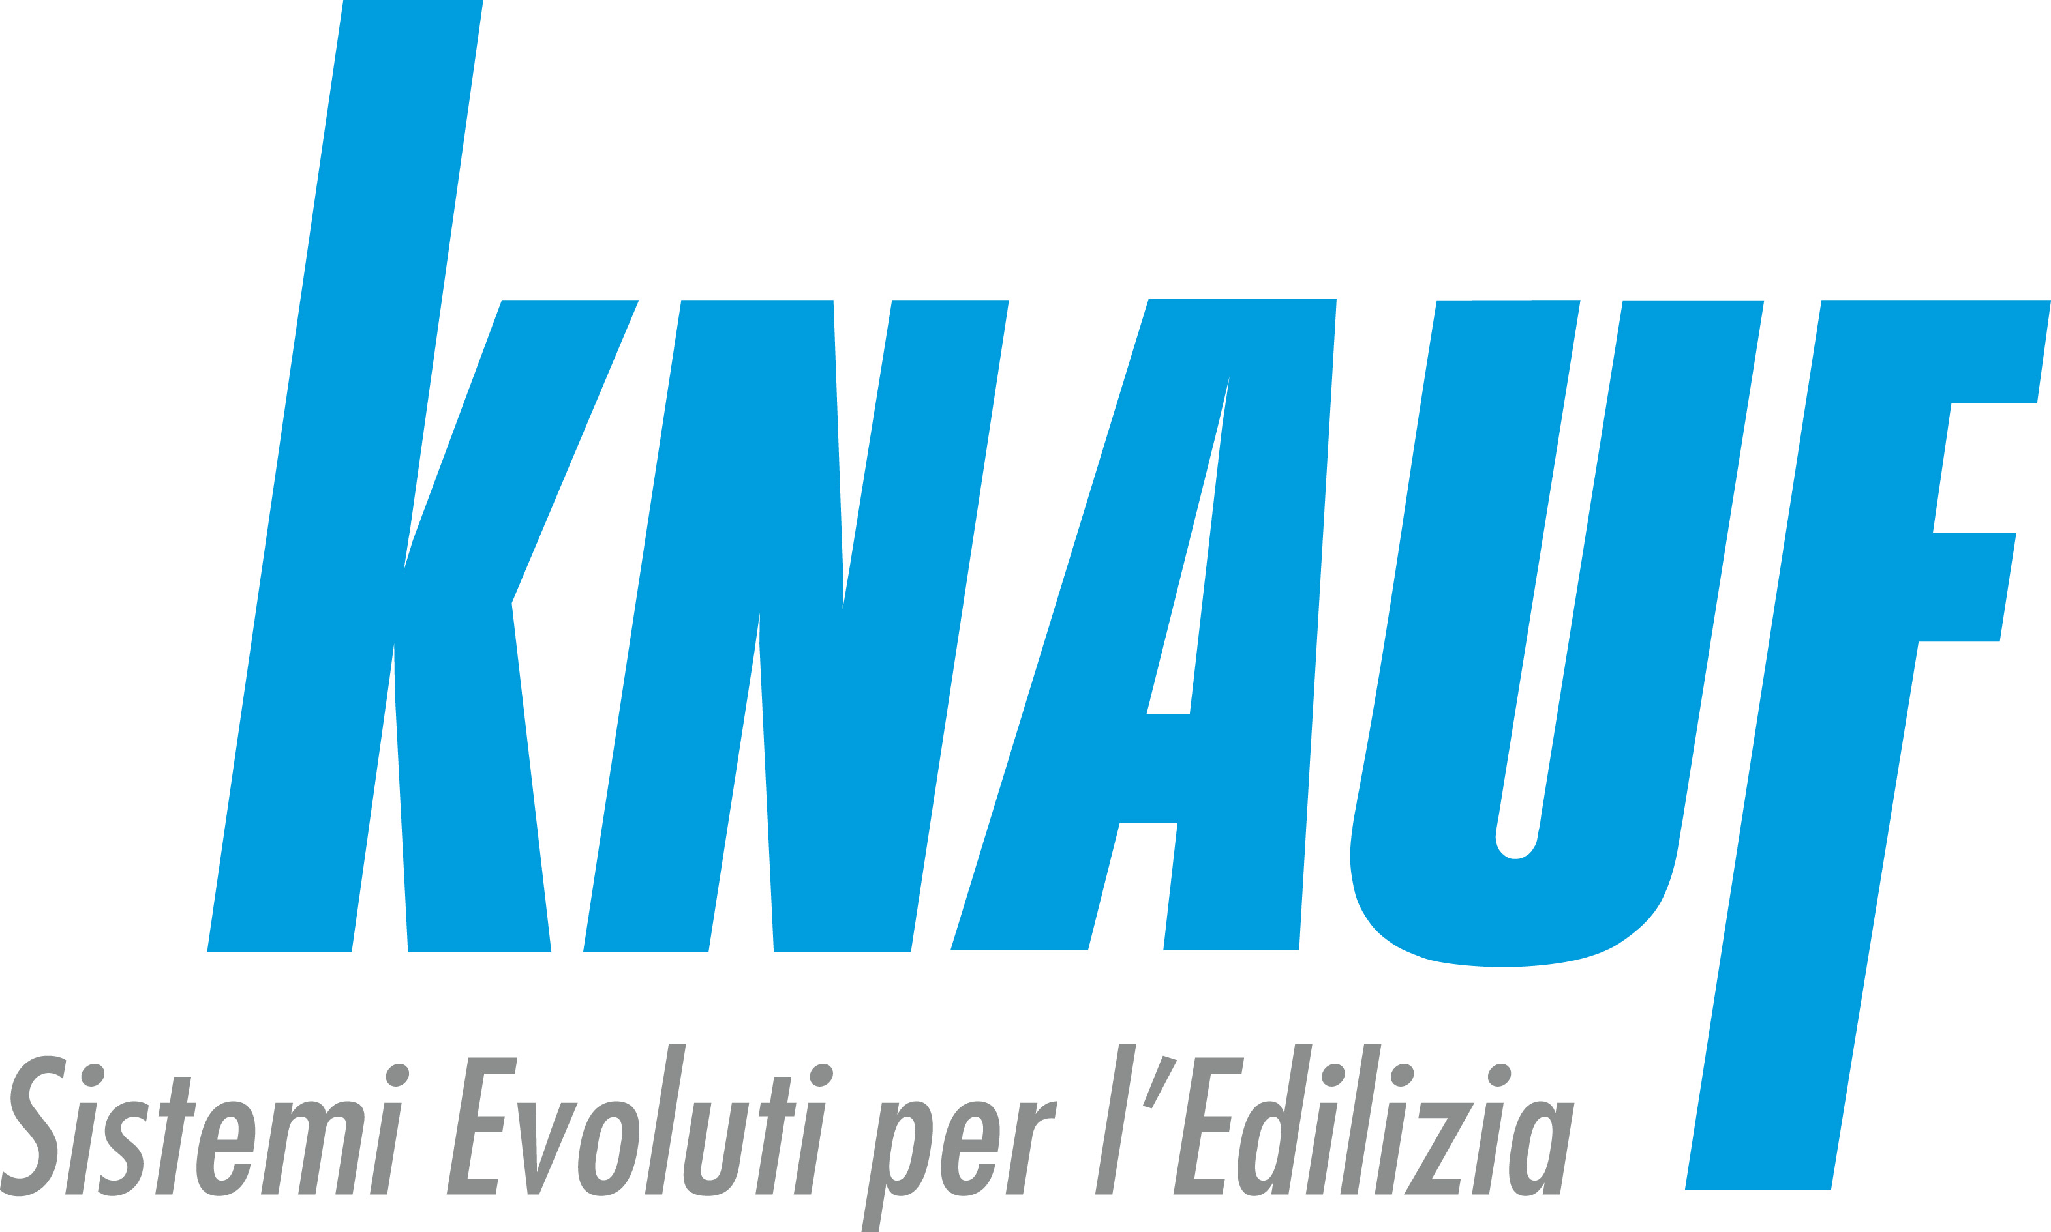

Press information:

Press Office
Fondazione Giorgio Cini onlus
Tel.: +39 041 2710280
Fax : +39 041 5238540
E-mail: stampa@cini.it
http://www.cini.it/press-release

International Press
Evergreen Arts
Sarah Greenberg
sgreenberg@evergreen-arts.com
+44 (0)7866543242

Italian Press
Ste.Max Eventi
Massimiliano Simonetta
stemax@stemaxeventi.it
+39 027 39 53 534

In collaboration with


With the support of


