Progressivo | Immagini | Didascalia
1 | 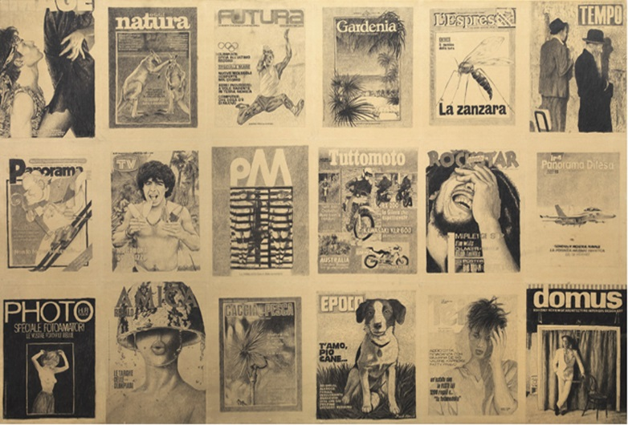 | Alighiero Boetti, Anno 1984, 1984, pencil on paper mounted on canvas, twelve elements, each 39 ⅜ in x59 in). Detail Courtesy Tornabuoni Art
2 | 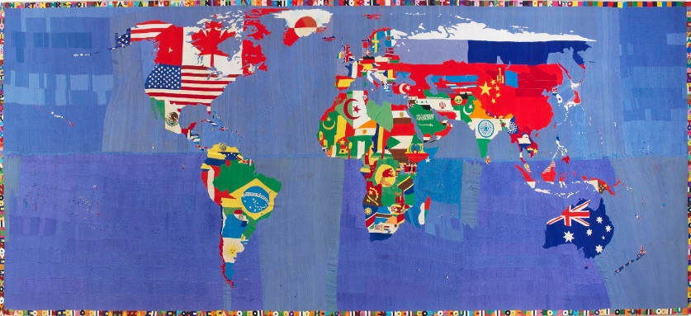 | Alighiero Boetti, Mappa, 1989-94, embroidery on canvas, 100x231,49 in. Courtesy Tornabuoni Art
3 | 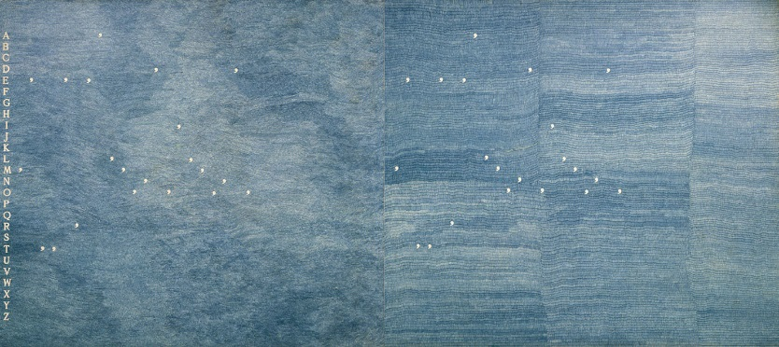 | Alighiero Boetti, Mettere al Mondo il Mondo, 1975, pen on paper mounted on canvas, 62,99x136,61 in. Courtesy Tornabuoni Art
4 |  | Alighiero Boetti, Aerei, 1989, ink and watercolour on photographic paper mounted on canvas, 59 x 118 ⅛ in (three  elements, each 59 x 39 ⅜ in). Detail. Courtesy ©Collection Carmignac, Paris
5 | 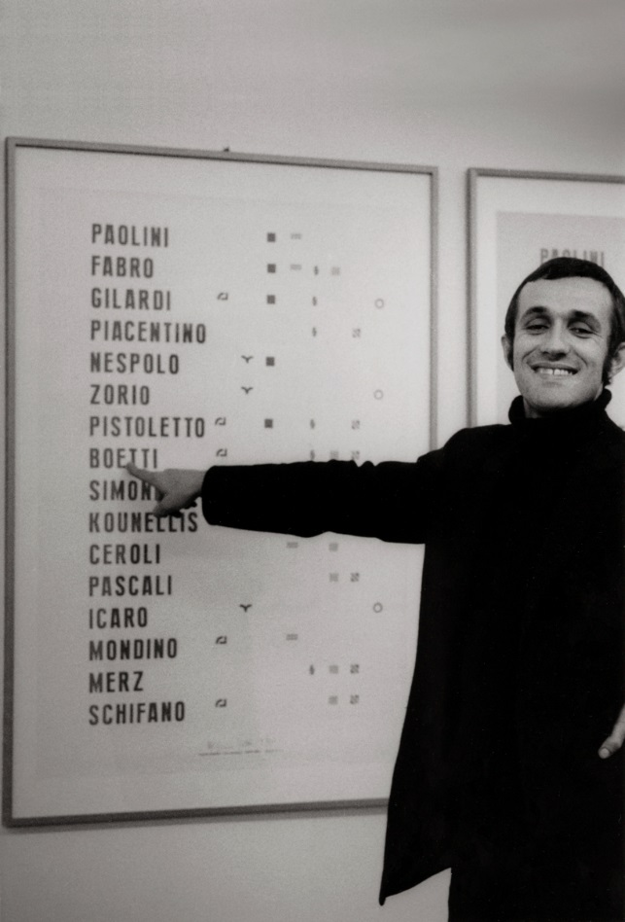 | Alighiero Boetti, Manifesto, Galleria Toselli, 1972. Photograph Paolo Mussat Sartor
6 | 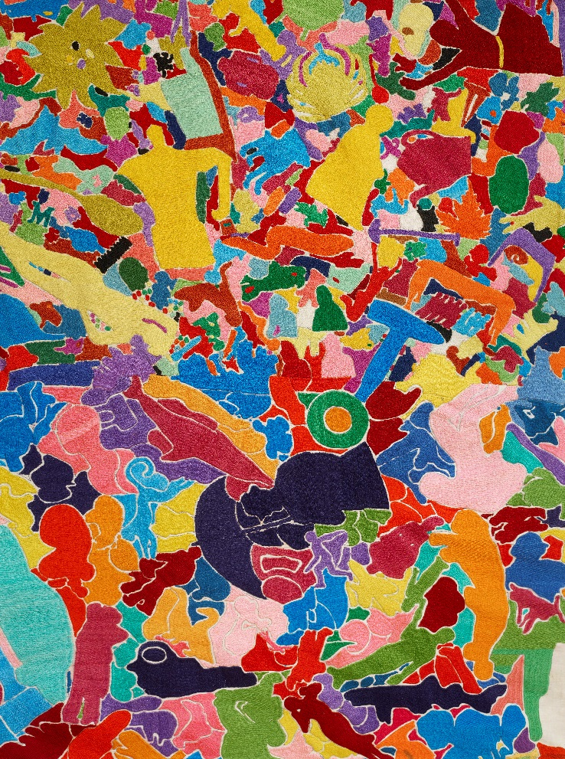 | Alighiero Boetti, Tutto, 1992-94, embroidery on canvas, 100 ⅜ x 234 ¼ in, detail. Courtesy Tornabuoni Art

