The Battle between Carnival and Feast

Figure with Dog, 2019  Courtesy Galerie Thaddaeus Ropac, London · Paris · Salzburg  © Adrian Ghenie | Olio su tela 240 x 210 cm | 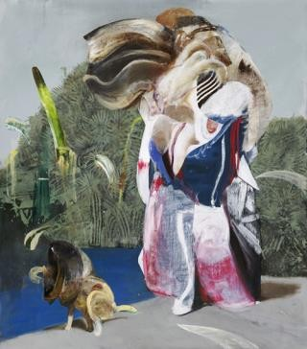
The Wall, 2019  © Adrian Ghenie | Olio su tela 250 x 240 cm | 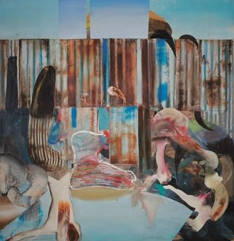
The Raft, 2019  Courtesy Galerie Thaddaeus Ropac, London · Paris · Salzburg  © Adrian Ghenie | Olio su tela 230 x 360 cm | 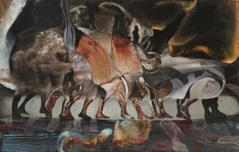
The Drowning, 2019  Courtesy Galerie Thaddaeus Ropac, London · Paris · Salzburg  © Adrian Ghenie | Olio su tela 190 x 295 cm | 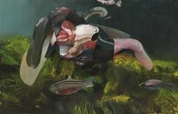

Self Portrait with Animal Mask, 2018  Private Collection  Courtesy of the artist and  Galeria Plan B Cluj, Berlin  © Adrian Ghenie | Olio su tela 150 x 100 cm | 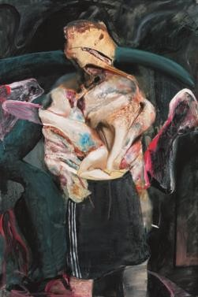
Self-Portrait with iPhone, 2018  Az Artgestion Collection, Bilbao  Courtesy Tim Van Laere Gallery, Antwerp  © Adrian Ghenie | Olio su tela 140 x 110 cm | 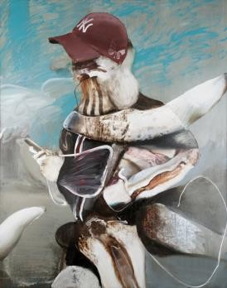
Untitled, 2019  © Adrian Ghenie | Olio su tela 55 x 45 cm | 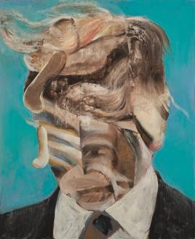
Untitled, 2019  Private Collection, Monaco  Courtesy Galeria Plan B Cluj, Berlin  © Adrian Ghenie | Olio su tela  45 x 45 cm | 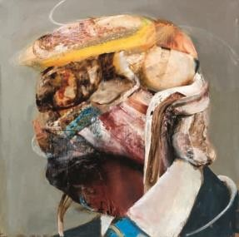
Untitled, 2018  Blenheim Art Foundation Courtesy Galerie Thaddaeus Ropac, London · Paris · Salzburg  ©Adrian Ghenie | Olio su tela  50 x 30 cm | 