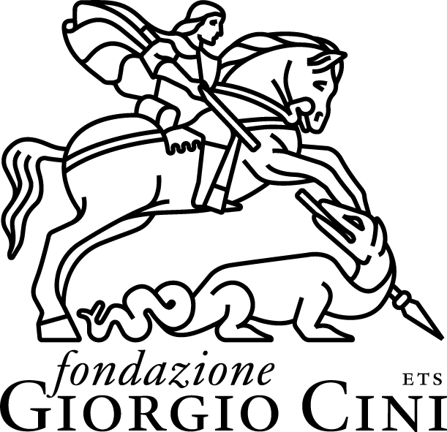

Fondazione Giorgio Cini ETS

The Fondazione Giorgio Cini was created in 1951 by Vittorio Cini to commemorate his son Giorgio, who had died tragically in an air crash on August 31, 1949. The Foundation is the earliest example in Italy of a private organization whose principal aims included humanistic studies at a time when collective interest was focused on economics, science, and technology. Vittorio Cini’s decision to make the Island of San Giorgio Maggiore the setting for his Foundation was a remarkably inspired move.

In fact, by choosing the island as the headquarters of the Foundation and including its restoration and redevelopment among the Foundation’s statutory aims, Vittorio Cini made his creation an heir to a centuries-old tradition: he gave it the historical role and vocation of the monastery whose legacy he wished to perpetuate.

The Foundation’s initial projects were focused on solving some of the urgent problems afflicting Italy and Venice in the postwar period. On the one hand, there was a need to train young people professionally and, on the other, there was a dearth of resources and facilities dedicated to scientific and cultural research.

Today the Fondazione Giorgio Cini is an internationally recognized cultural institution which continues to draw inspiration from its original vocation and at the same time plays a leading role as a center for studies and a venue for meetings and debate on current issues. Its academic activities – research projects and events aimed at improving our “knowledge of the world” – continuously interact with thinking on the current political and social scene aimed at promoting multidisciplinary approaches and experimenting with exchanges between forms of knowledge and various scientific and professional cultures. The intention is thus also to provide innovative tools for analysis and comprehension, as well as propitious opportunities for “building a new world.”

