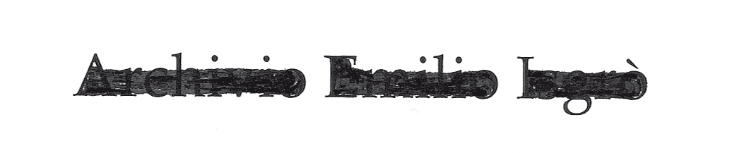

Archivio Emilio Isgrò, founded in 2011, focuses on the promotion and dissemination of the artistic, literary, theatrical and critical works of the artist, as well as the cataloguing of his entire visual oeuvre.
Thanks to the effort to gather documentation on the life and works of Emilio Isgrò, the Archive provides a place for study and research, also for degree theses that investigate the evolution of the artist’s poetics and the Italian neo-avant-garde movement he has traversed with great originality.
Parallel to these activities, the Archive also moves forward to document the works held by collectors, for the purpose of the preparation of a catalogue raisonné.
Over the years the Archive has developed numerous collaborations with public and private institutions, include the large retrospective in Milan at the locations of Palazzo Reale, Gallerie d’Italia and Casa Manzoni in 2016.
Alongside the Archive, in March 2019 the Istituto Emilio e Scilla Isgrò has been opened, with the main objectives of providing access to the artistic and intellectual work of Isgrò, and the promotion of erasure as an artistic language.
The space of the Institute is composed of Rooms for the display of a precise historical selection of the visual output of Isgrò, and by the Hall set aside for artistic and literary events (including book presentations to poetry readings), to reinforce awareness of the fact that literature and poetry represent necessary factors for the comprehension of contemporary art as a whole. The Institute is open to the public for guided visits in groups, by reservation only.
Archivio Emilio Isgrò is located in Milan at Via Martiri Oscuri 5, and is directed by Scilla Isgrò, who relies on the collaboration of Giulia Crespi and Costanza Ballardini, and the consulting of Marco Bazzini and Matteo Reale for the literary aspects.

